Order No:45 of 2025
Dated:12-07-2025

Subject: Modification to Constitution of Sexual Harassment Committee
This is in partial modification to Office Order No. 44 of 2025, dated 11-07-2025, regarding the constitution of the Sexual Harassment Committee. The original order is hereby amended to include the following members as part of the committee:
- All In-Charges/Heads of Departments (HODs) of the institution
- The Section Officer of the institution
The committee shall proceed with its assigned duties, including the investigation of reported cases, with the inclusion of the aforementioned members effective immediately.

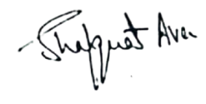

No: KGP/Estt/2025-26/573 Dated:12-07-2025

Principal
Kashmir Government Polytechnic College
Srinagar

Copy to the:
1.All concerned for information.

